RESEARCH PROJECT
REPORT

DATA ANALYSIS ON RATION DISTRIBUTION TO FAIR PRICE SHOPS USING PANDAS AND MATPLOTLIB

ACKNOWLEDGEMENT

I would like to express my heartfelt thanks to Prof. P. Radha Krishna, Professor of Computer Science Department, National Institute of Technology Warangal and Mr. Vishnu Kumar, Ph.D. Research scholar, department of CSE for guiding me throughout my project ‘Ration distribution in Fair Price Shops using Pandas’.

GOTTAM TEJASREE

Place: Warangal
Date:28 July 2023

AIM/OBJECTIVES
- A comprehensive study for data analysis so that it will be effective for the public distribution system (PDS)
- Exploring pandas and NumPy algorithms and visualising the dataset.
- Develop a common data model (CDM) based on KPIs

- Analysing individual state specific data models and arrive at integration specifications.

- This adapter will consist of data cleansing, data transformations, triangulation and other mechanisms to achieve the desired schema/data model.

- It can be a single step or multistep process based on gap between original schema and the desired target schema.

TABLE FOR CONTENTS: -

1.Introduction -------------------------------------------------------- 9
2. Data analysis using python libraries-----------------------------9
2.1 Highlights of panda’s library-------------------------9
2.2 NumPy library-----------------------------------------10
2.3 matplotlib library -------------------------------------11
2.4 Seaborn-For visualizing statistical data---------------------11

3. Public Distribution and Ration Allocation------------------11
3.1 Collection of food grains---------------------------12
3.2 eligibility for pds ------------------------------------12

4. Dataset and queries---------------------------------------------11
4.1 About the dataset--------------------------------------11
4.2 Code explanation--------------------------------------12

5. Conclusion and future work ----------------------------------28
6. References------------------------------------------------------ 28

FIGURES: -
________________________________________________________________

Figure 4.1 -Represents total sugar allocated across all districts in Telangana state.
Figure 4.2 and 4.3-Bar graph representing district with less allocation of kerosene (Liters).
Figure 4.4 and 4.5- Line chart and area chart representing rice allocation to different ration card holders in all the districts.
Figure 4.6 - Bar graph representing average wheat allocation for each district.
Figure 4.7- Bar graph representing average number of transactions in each district.
Figure 4.8 – Represents ration allocation to different categories in Medchal district.
Figure 4.9 - Bar graph representing districts with minimum and maximum number of transactions.
Figure 4.10 – Line chart representing minimum and maximum number of transactions in each district
Figure 4.11 – Stacked bar graph showing composition of each allocation across all districts.
Figure 4.12 - scatter plot comparing other shop transactions with total transactions in each district.
Figure-4.13 - average number of transactions for the offices amangal, nadipet, vikarabad, undavelly, siricilla, Adilabad and khila Warangal
Figure-4.14 composition of number of transactions and other shop transaction

1). INTRODUCTION:
Data analytics is a broad term which is widely used now a days in almost all fields. It is based on computer tools which helps to collect data from various resources and analyse it using software packages and draw useful decisions for business development.
Data Visualisation helps to view then analysed data in the form of charts, graphs and trends, heatmap visualisations which are considered to make quick decisions from the data.
In this project data analysis is performed on ration distribution to fair price shops of Telangana in 2023 January. Some useful information is drawn from the data using python libraries such as pandas, NumPy, matplotlib, seaborn etc and visualisation tools such as bar graphs, pie charts, line charts etc.
2).DATA ANALYSIS USING PYTHON LIBRARIES:
2.1. HIGHLIGHTS OF PANDAS LIBRARY:
Pandas is a python library for data analysis.
The main aim of pandas is to solve practical and real-world data analysis in python. The advantage of pandas is it is most powerful and open-source tool that is available in any form of language.
- Anyone can access this fats and flexible tool with free of cost
- Pandas helps to read and import data in various formats like csvfile, excel file, SQL database, HDF5 format
- It also helps to combine, transform, merge datasets
- Python with combination of pandas is widely used various fields such as hospitals, finance, statistics etc.
- two main python libraries are:
- 1.matplotlib used for data visualization
- 2.numpy for mathematical operations.
- Using pandas library, we can perform following operations:
- creating data frame
- indexing and slicing:
- sorting Data Frame: -
- manipulating data frame
- knowing duplicates
- handling missing data
- data filtering and conditional changes
2.2. NUMPY:
NumPy is also a python library usually operates arrays.
NumPy is created in the year 2005, it Is also an open source accessible for everyone.
Partially NumPy is written in Python but most of the [art written in C or C++
It usually works on:
assigning values
array operations
arithmetic operations
statistical operations

2.3. MATPLOTLIB LIBRARY:
Using plot() method we can visualise the data using wide variety of plots like histograms, scatterplot, bar plot etc
So that these figures can be customised as per our requirement and thus helps us to find variable correlation
Matplotlib helps the user to solve the data more easily and decrease the time consumption.
2.4 SEABORN-FOR VISUALIZING STATISTICAL DATA:
An open-source, free, and Matplotlib-based data visualization package is called Seaborn. Many data scientists like seaborn over matplotlib because of its high-level interface for creating eye-catching and educational statistical visuals.
Simple controls in Seaborn let you focus on the story and learn how to draw it. You must master Seaborn, a library that you must own.
Making visualization a key component of data exploration and understanding is Seaborn's goal.

3.PUBLIC DISTRIBUTION SYSTEM AND RATION ALLOCATION: -
In ordre to maintain food economy in our country, Public Distribution System has a important role in government policy. The Central Government and the State/UT Governments share oversight of PDS. PDS general aim is distributing food grains to scarcity areas.
The Food Corporation of India (FCI), a subsidiary of the Central Government, is in charge of obtaining, storing, transporting, and allocating food grains in bulk to the State Governments. The State Governments are in charge of carrying out the operational duties, such as allocating resources within the State, determining which households qualify, issuing ration cards, and monitoring the operation of Fair Price Shops (FPSs), among other things. Wheat, rice, sugar, and kerosene are now the commodities allocated to the States/UTs for distribution under the PDS. Pulses, edible oils, iodized salt, spices, and other commodities of mass consumption are also distributed by several States/UTs through PDS shops.
PDS prevents food grain supply and price volatility because the product is completely dependent on the monsoon. After selling the required amount in the good harvest year, the government increases the buffer stock position from which it will again sell in the bad harvest year. Through the public distribution system, an environment favourable for deliberate economic development is produced during inflation. The government preserves India's food grain self-sufficiency by regulating the minimum quantity of imports. There are four ways the government can get food grains from domestic sources. In the open market purchase technique, the Government offers producers higher prices than what the traders are willing to provide, but there is no obligation on the producers.

3.1 COLLECTION OF FOOD GRAINS:
The central government oversees the procurement, storage, transportation, and bulk distribution of food grains to state governments through Food Corporation of India (FCI). The States/UTs receive allocations of wheat, rice, sugar, kerosene, legumes, edible oils, iodized salt, and spices for widespread distribution and consumption. The Government buys food grains from the farmers at fair prices and pays them fairly in order to avoid the traders' meddling. For less money, these food grains are offered to underprivileged customers
3.2 ELIGIBILITY FOR PDS SCHEME:
India's rationing system defends underprivileged consumers against the competition of wealthy consumers who enjoy greater purchasing power and income levels. In large cities, there is a high level of income inequality, which is problematic for the poor. Rationing was therefore implemented in major cities to safeguard consumer interests. Rationing has been implemented to stop industrial workers' greater cost of living. However, the primary issue with PDS is that it primarily works in metropolitan areas, though there are more low-income households there.

All the families below poverty line, families which do not have family members between 15 to 59 years of age, families containing disabled members, and families where members do not have permanent job and work as casual labour all these people are eligible for PDS system.
* PDS policy has declared as below poverty line card holders should be provided with 35kgs
* of food grains and above poverty card holders should be provided with15 kgs of food grains.
* One Nation One Ration card helps the migrant works to get their ration where they work.

4.DATASET AND QUERIES :-
4.1 ABOUT DATA SET:
The dataset shop-wise-trans-details_1_2023.csv provides information about the FP Shop Distribution Data in Telangana. The columns contained and their abbreviation are given below:
distCode: code of ration allocated district
distName: District name to which ration allocated
noOfRcs: represents number of ration cards
noOfTrans: represents number of transactions
riceAfsc: represents rice allocated to Anthyodaya Food Security Cardholders.
riceFsc: represents rice allocated to food Security cards.
riceAap: represents rice allocated to Annapurna cards.
Values: -
noOfRcs: counted as Number of Cards
noOfTrans: counted as number of transactions
ricefAfsc: counted as number of transaction.
riceFsc: counted as number o f transactions.
riceAap: counted as number of transactions
wheat, sugar, rgdal, salt: taken in kgs
kerosene: taken in
litres
totalAmount: taken in rupees

4.2 code explanation
code-4.1: importing dataset
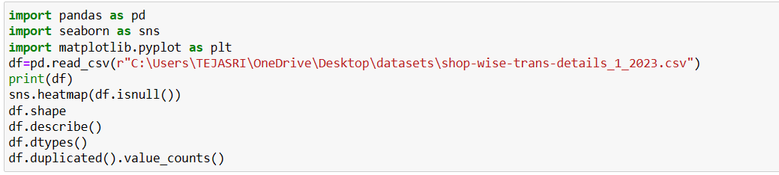
pandas: used to read and operate data from files like csv, excel
seaborn and matplotlib: used to create visuals
shape(): used to find number of rows and columns
describe (): used to find mean, standard deviation, quartiles, min and max values
dtypes(): talks about whether column values are integer, float, string

code-4.2 DISTRICT WITH MAXIMUM NUMBER OF TRANSACTIONS
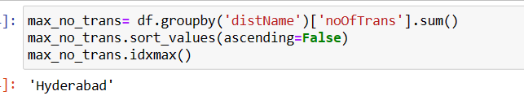

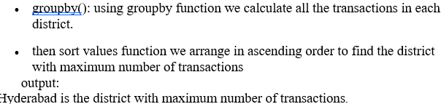

CODE-4.3 SHOP GOT LEAST ALLOCATION OF RICE
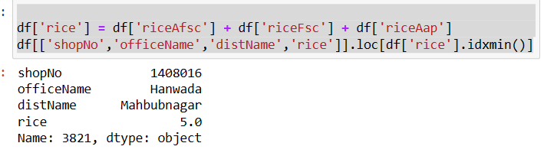
- create a new column(rice) where rice allocated to anthyodaya food security cards(riceAFsc), food security cards(riceFsc), Annapoorna cards(riceAap) are added
- then using idxmin function in rice column we find shop number that has least allocation of rice
- Output:
- Hanwada(office name) of Mahbubnagar district has least number of transactions for rice.

CODE-4.4 SHOP NUMBER THAT ALLCOATED WITH HIGHEST AMOUNT
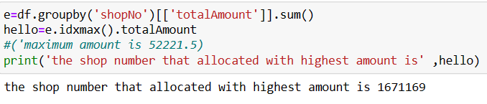

> Using idxmax function find shopnumber that s pent maximum amount

> Using groupby function find total amount spent by each shop number.

Code-4.5 SUGAR ALLOCATION ACROSS ALL THE DISTRICTS
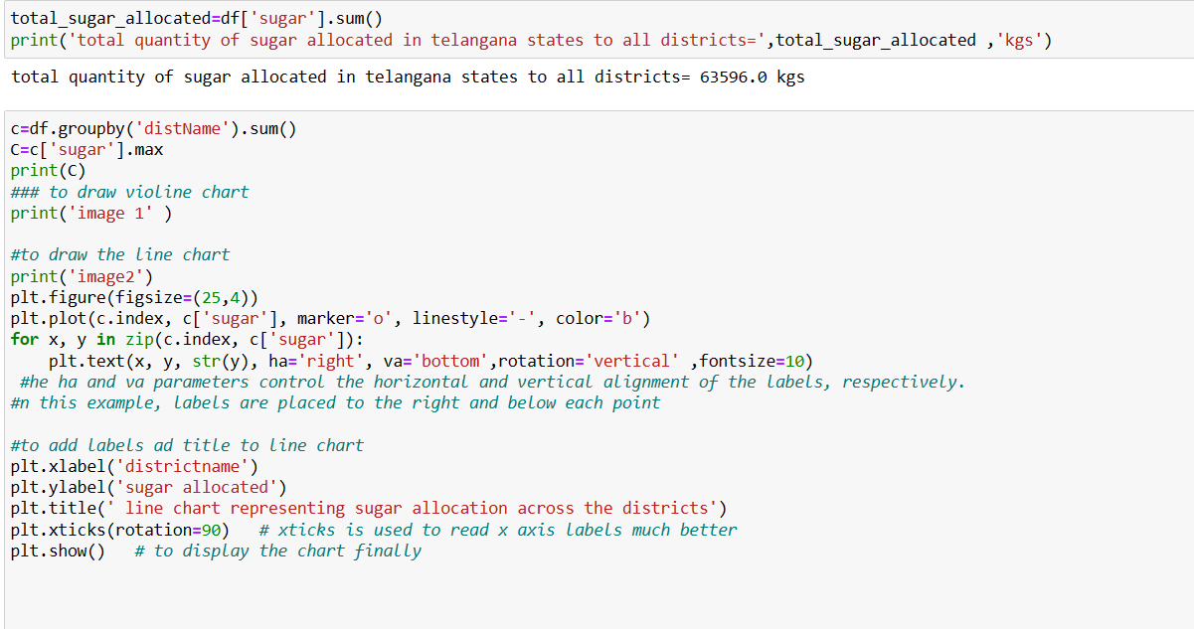
- to find total sugar allocated in Telangana state we use sum function which adds the whole values in sugar column
- to find district with more sugar allocation we first use group by function, so that total sugar allocation in each individual district
- to have a better understanding we use visualising tool called line chart
- from the below line chart, it depicts that Hyderabad is allocated with more amount of sugar(21591kgs) then Nalgonda (11634 kgs) and then after Medchal (6339 kgs).

Figure-4.1 -Total sugar allocated across all districts in Telangana state
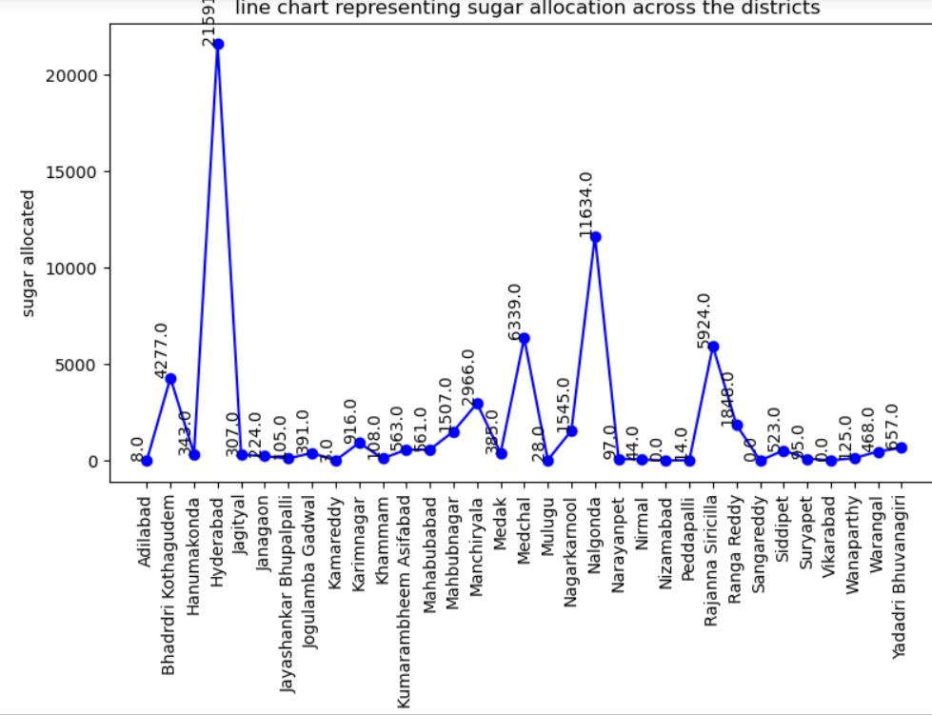

Code 4.6 district with minimum kerosene allocation

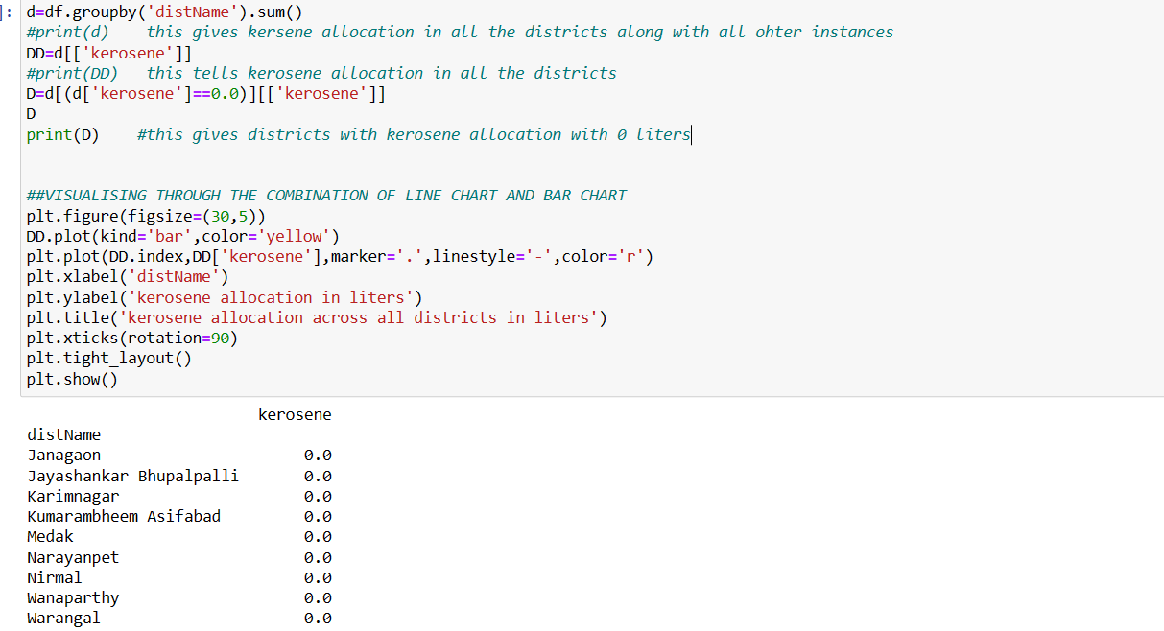
- using group by function we add kerosene allocation for each district
- using below line chart/bar graph we can find the districts with minimum allocation of kerosene

Figure-4.2 – bar graph representing districts with less allocation of kerosene (Liters)
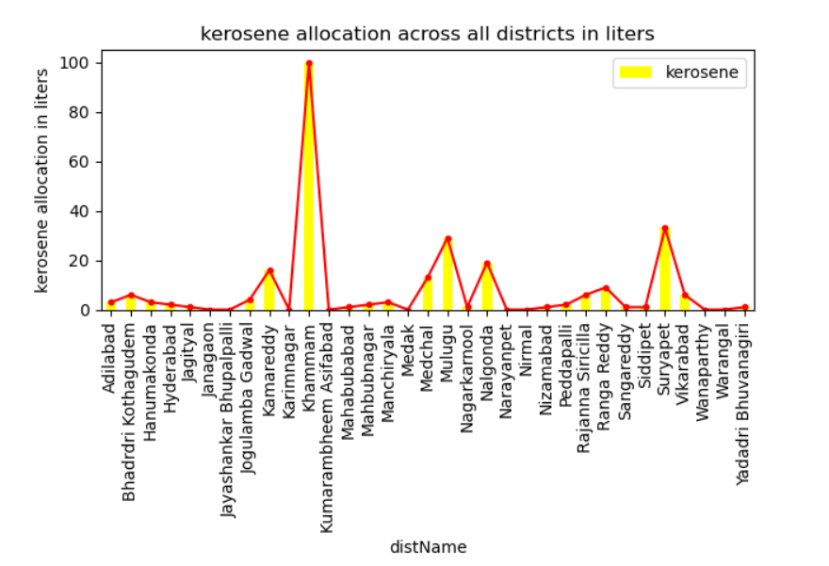

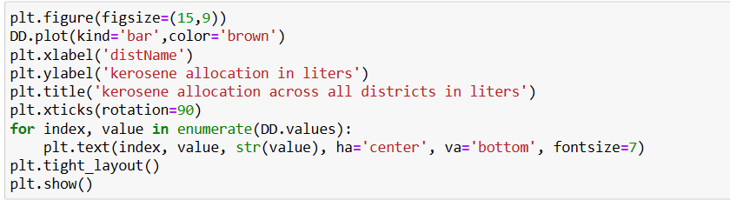
Figure 4.3
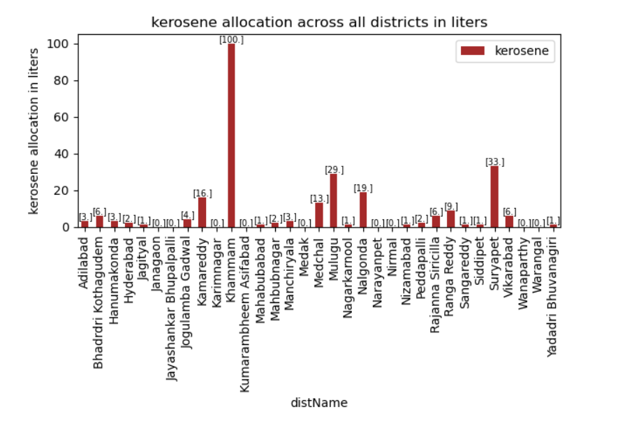

Code-4.7 HIGHEST AND LOWEST NUMBER OF TRANSACRTIONS
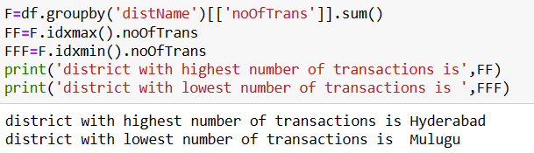
- Adding number of transactions of each district using groupby function

Using idxmax and idxmin find district name with maximum and minimum transactions.

CODE 4.8 compares the rice allocations to riceAFsc, riceFsc, riceAap in all districts

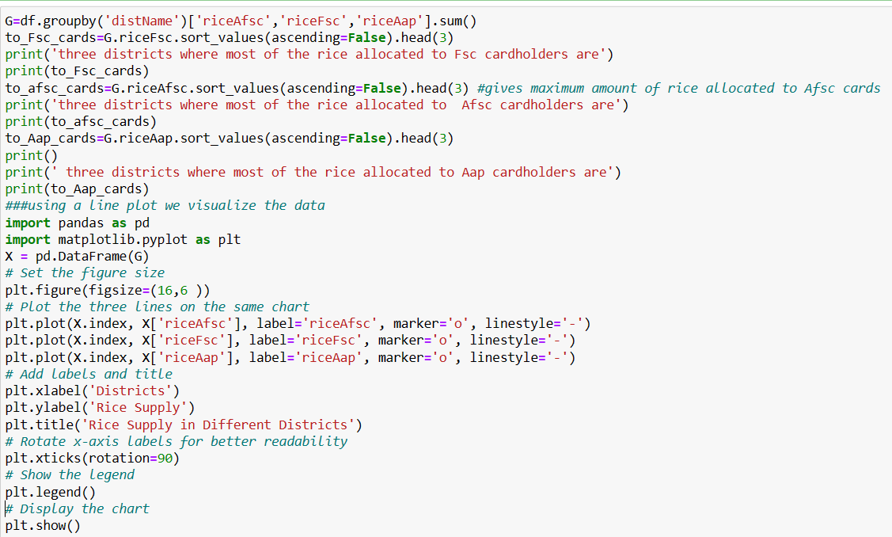
To compare the rice allocations to different cards we first add the allocations to different shops in each district for different category cards. then using a LINE CHART, we compare rice allocation to all three categories of ration cards in each district.
output:
from the below graph we say that most the quantity of rice is allocated to Fsc cards then to AFsc cards and then to Aap cards in almost all districts.
Fsc cards:
Hyderabad district is allocated with 1,06,43,273 kgs of rice to Fsc cards(highest).
Ranga Reddy district is allocated with 11,61,684 kgs of rice to Fsc cards (2nd highest).
Medchal district is allocated with 78,92,521 kgs of rice to Fsc cards (3rd highest).
Jayashankar Bhupalpalli is allocated with least amount rice to Fsc cards with 13,49,482 kgs.
Afsc cards:
Ranga Reddy 11,61,684 kgs (highest amount of rice allocation to Afsc cards among all districts)
Hyderabad 9,52,974 kgs (2nd highest)
Nalgonda 8,91,290 kgs (3rd highest)
Mulugu 236301 kgs (least amount of rice allocation to Afsc cards among all districts)
Aap cards:
Nizamabad 7700 kgs (highest)
Hyderabad 7420 kgs (2nd highest)
Kamareddy 6480 kgs (3rd highest)
Mulugu 0.0 (least)
Yadadri Bhuvanagiri 0.0 (least)

Figure-4.4-linechart representing rice allocation to different ration card holders in all the districts
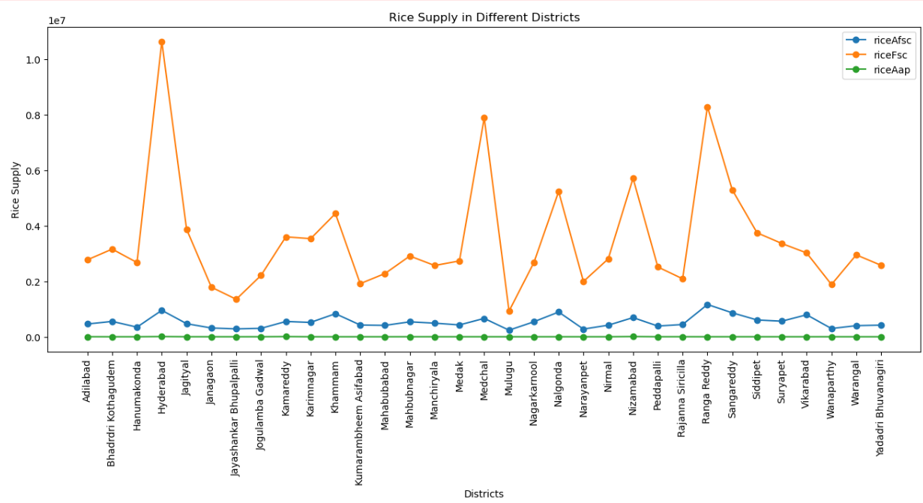

Figure-4.5 AREA CHART
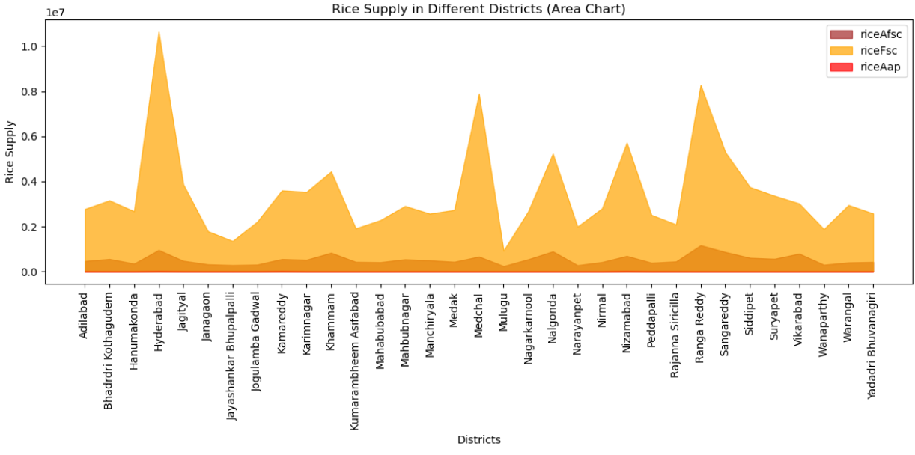

Code 4.9 average wheat allocation in each district
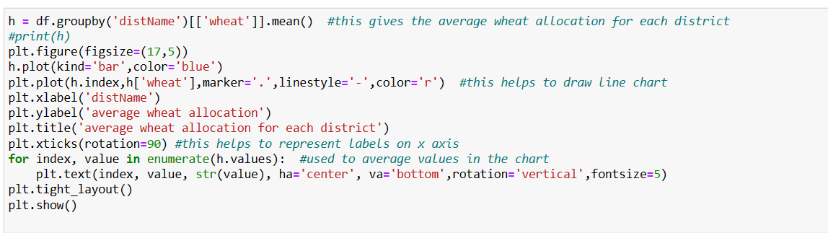
from the below bar graph, it shows that average wheat allocation is more in Hyderabad then after medchal and Ranga Reddy when compared to all other districts.
most of the districts are allocated with 0kgs on an average.

Figure-4.6 bar graph representing average wheat allocation across all the districts

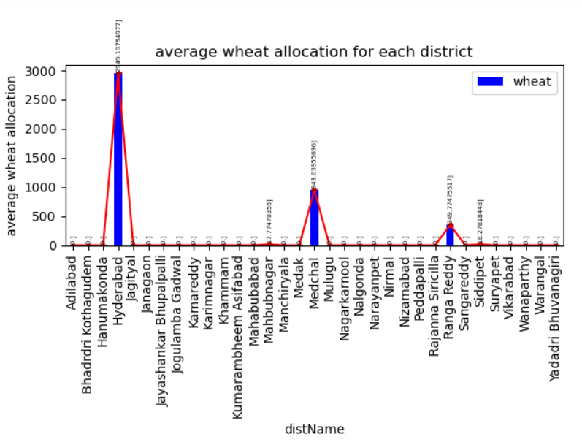

Code 4.11 comparison of ration allocation across all districts
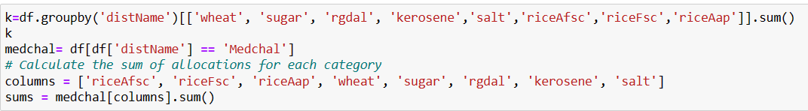
Output:
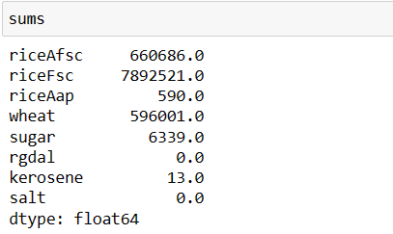
Code 4.10 average number of transaction of each district
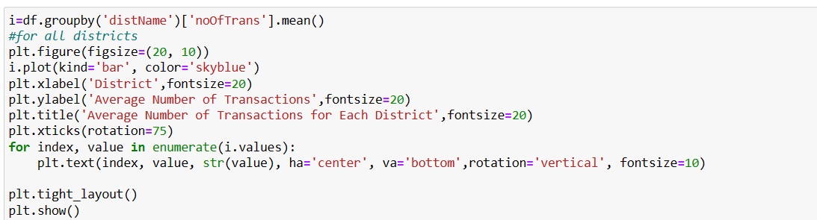
- Using group by function and mean function we group the districts based on number of transactions.
- Below bar graph shows Hyderabad has 895.5 transactions as highest average transactions.
Figure-4.7 bar graph representing average number of transactions in each district
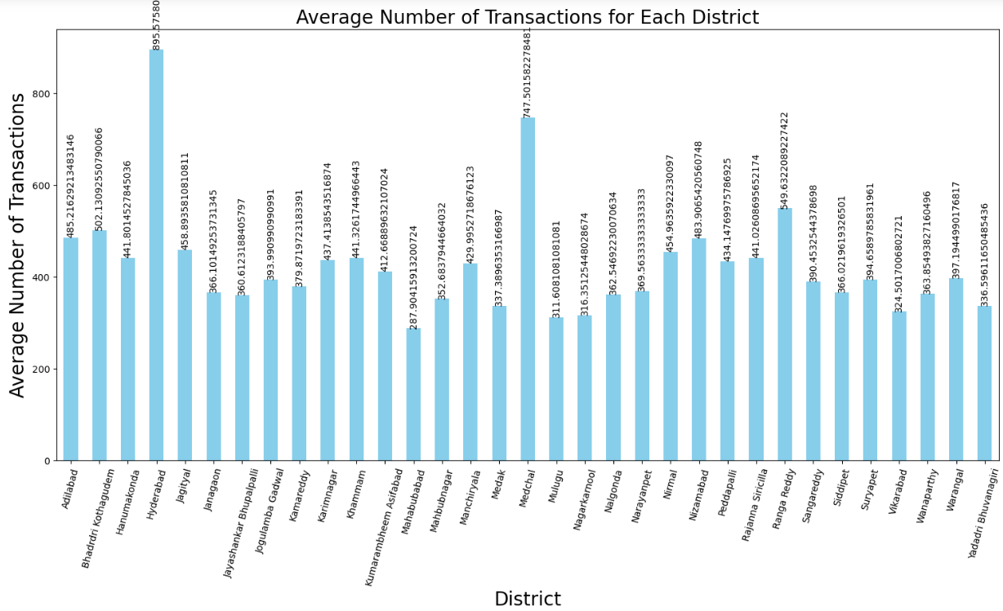

Visualising using a pie chart
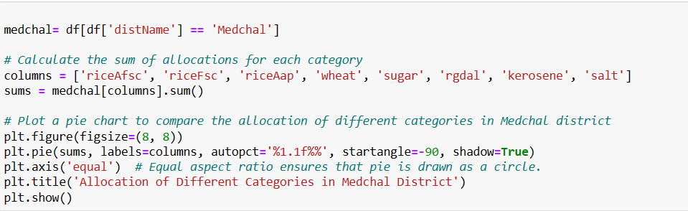

Figure-4.8 ration allocation for each category in medchal district
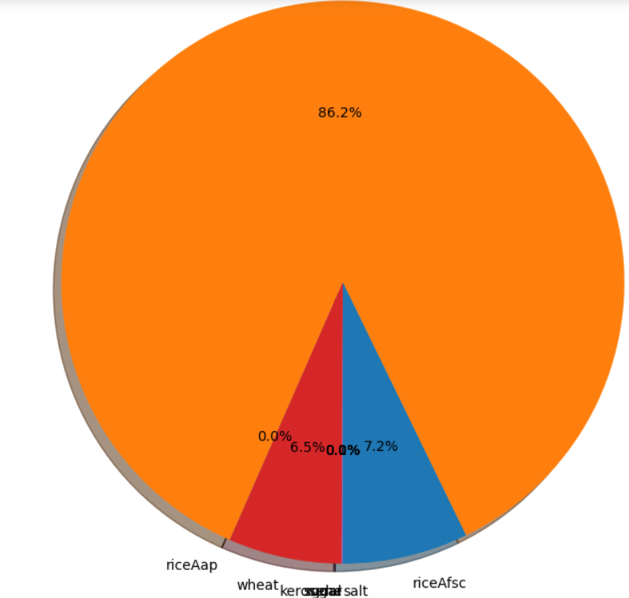
riceAfsc 6,60,686 kgs
riceFsc 78,92,521 kgs
riceAap 590 kgs
wheat 5,96,001 kgs
sugar 6,339. kgs
rgdal 0. Kgs
kerosene 13 Liters
salt 0 kgs

code 4.12
comparing the transactions in each district during the ration allocation
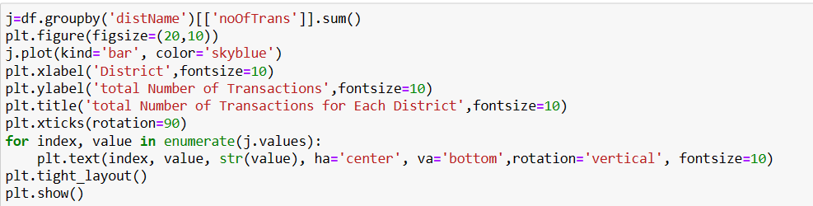
we compare the transactions using a bar chartoutput: DISTRICTS WITH MAXIMUM AMOUNT OF TRANSACTIONS
Hyderabad with rupees 5,84,811/-
Ranga Reddy with rupees 5,05,112/-
DISTRICTS WITH LEAST AMOUNT OF TRANSACTIONS
Jaya Shankar Bhupalpalli Rs 99529
Mulugu Rs 69177
Figure-4.9 bar graph representing districts with minimum and maximum amount of transactions
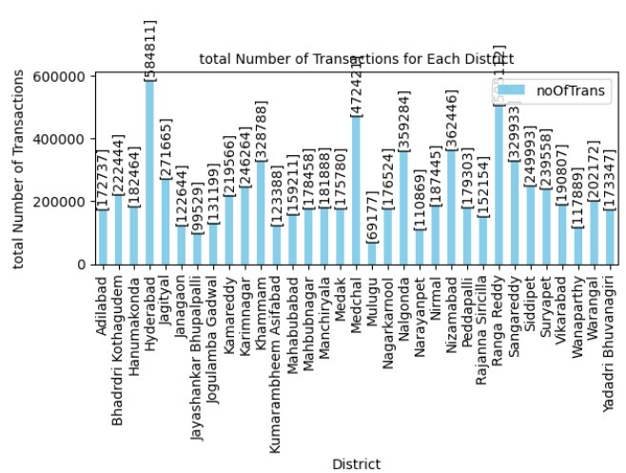

Figure 4.10 line chart
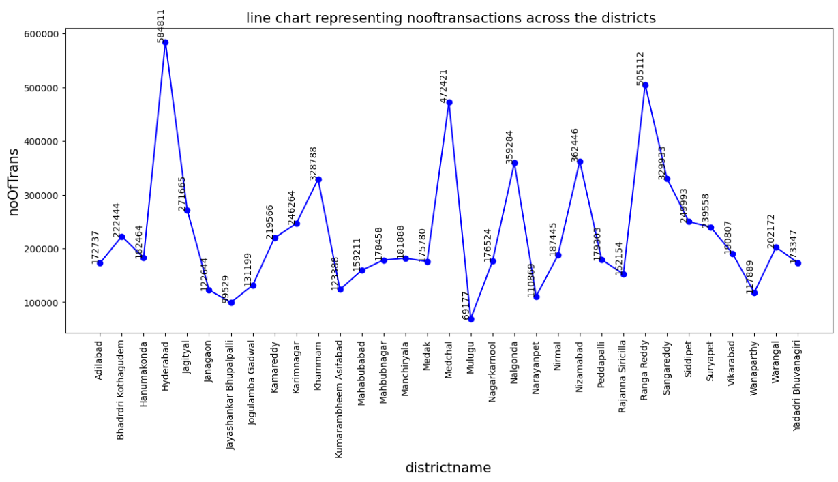
Code4.13- comparing allocation of rice wheat sugar rgdal kerosene salt for all districts
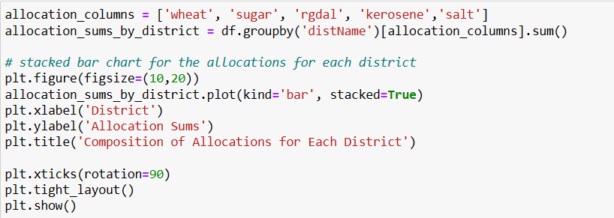
In the above code xticks(rotation=90) used to represent x labels in vertical direction.
composition of wheat allocation is more in districts Hyderabad, Ranga Reddy and Medchal
Figure-4.11 stacked bar graph showing composition of each allocation across all districts
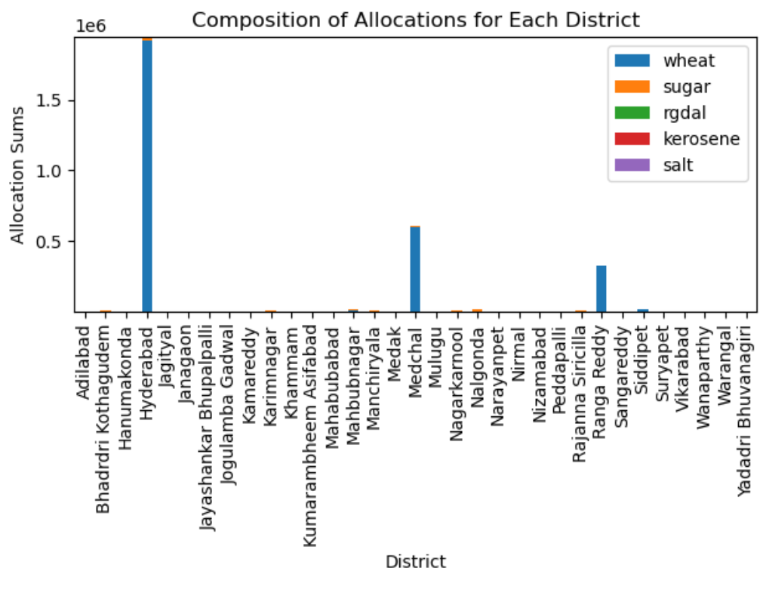
Code; 4.14
compare other shop transactions vs number of transactions
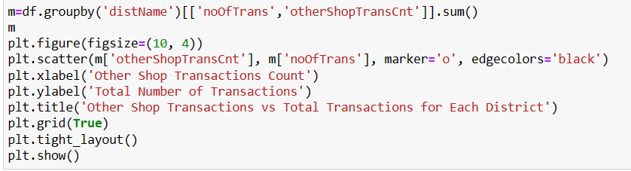

Figure-4.12comparing other shop transactions with total transactions in each district
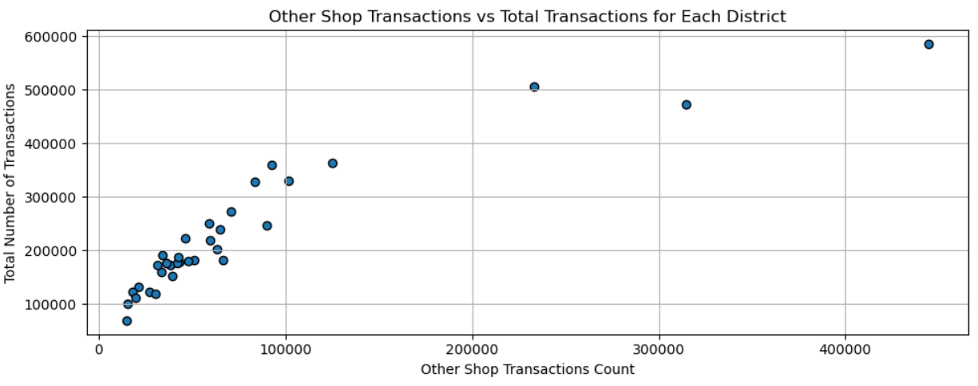
From the above code we first group the data by 'distName' using groupby () and calculate the sum of "noOfTrans" and "otherShopTransCnt" for each district using sum (). Then, we created a scatter plot using plt. scatter () with "otherShopTransCnt" on the x-axis and "noOfTrans" on the y-axis.
The scatter plot will show individual data points for each district. where the x-coordinate represents the "otherShopTransCnt" (count of transactions with other shops) and the y-coordinate represents the "noOfTrans" (total number of transactions). WE CAN ANALYSE THAT THERE IS A STRONG CORRELATION BETWEEN "noOfTrans" and "otherShopTransCnt" BECAUSE the points on the scatter plot ARE closely clustered along a rising line.

Code 4.15:
average number of other shop transactions count for offices amangal, nadipet, viakrabad, undavelly, Siri Cilla, Adilabad, khila Warangal.

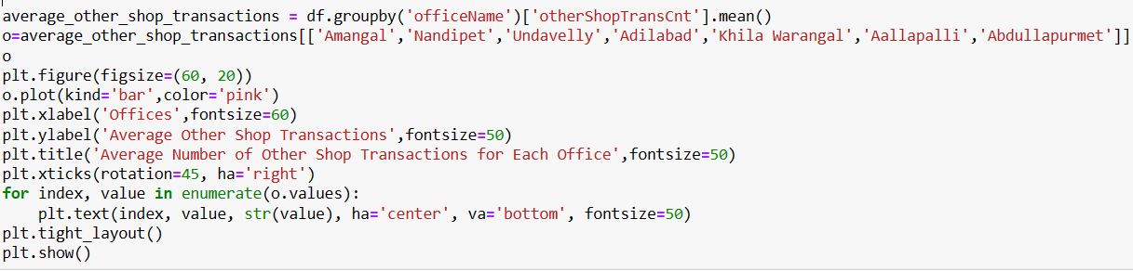

Figure-4.13 average number of transactions for the offices amangal, nadipet, vikarabad, undavelly, siricilla, Adilabad and khila Warangal
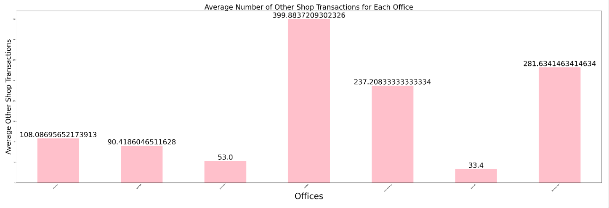

Code 4.16

offices with average total allocation
gangaram office has minimum average total allocation medipally has highest average total allocation

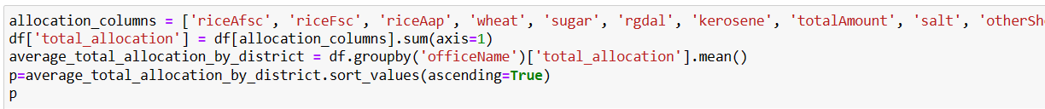

Code 4.17

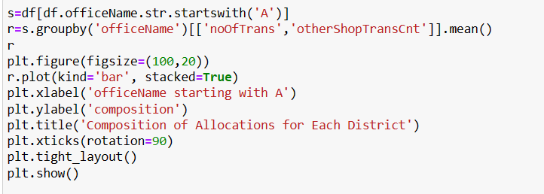

Figure-4.14 composition of number of transactions and other shop transaction
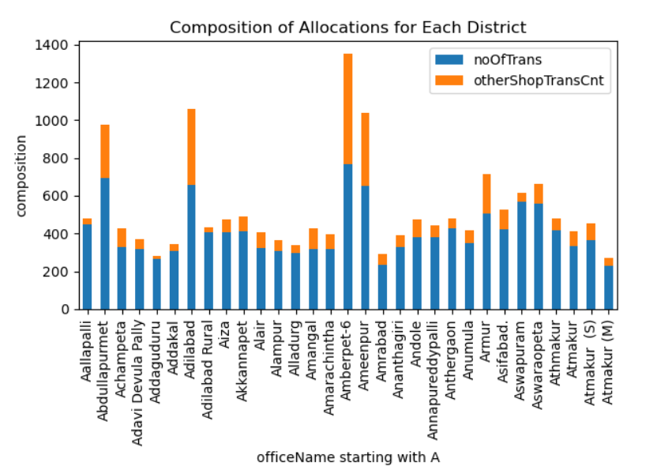

Code 4.18
Ration card holders receiving above and below 15kgs of sugar in Karimnagar district
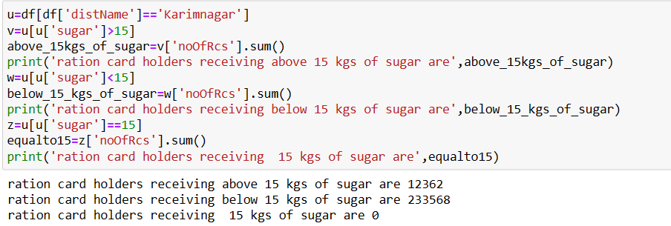

5.CONCLUSION AND FUTURE WORK: -
This project describes how several kinds of libraries are used for Python data analysis. Visualising tools like bar graphs, line charts, pie charts helped to obtain quick over view about the dataset.
In order to derive relevant insights and make wise judgments, data analysis is a crucial process that comprises inspecting, purifying, converting, and interpreting data.
Patterns, trends, correlations, and anomalies can be found through this data analysis technique, aiding in a better understanding of the underlying causes of a given occurrence or issue.

FUTURE WORK: -
By including future projections, the project can be made even better.

6. REFERENCES: -
  - https://hevodata.com/learn/data-analytics-and-visualization/
  - https://nfsa.gov.in/portal/PDS_page
  - https://data.telangana.gov.in/search/?fulltext=shop-wise-trans-details_1_2023
  - https://www.aplustopper.com/essay-on-public-distribution-system-in-india/

  - https://en.m.wikipedia.org/wiki/Public_Distribution_System_(India)
  - https://www.tutorialspoint.com/explain-how-python-data-analysis-libraries-are-used

